**Name (netid):** Greg Harrison (gdh3)

**CS 445 - Project 4: Image Based Lighting**

**Total Points Claimed 140 / 210**

**Core**

1. Recovering HDR maps
   1. Data collection 20 / 20 (recorded in B&W)
   2. Naive HDR merging 10 / 10
   3. Weighted HDR merging 15 / 15
   4. Calibrated HDR merging 15 / 15
   5. Additional HDR questions 10 / 10
2. Panoramic transformations 10 / 10
3. Rendering synthetic objects 30 / 30
4. Quality of results / report 10 / 10

**B&W**

1. Additional results 20 / 20
2. Other transformations 0 / 20
3. Photographer & Tripod removal 0 / 25
4. Local tone-mapping operator 0 / 25

**Recovering HDR maps**

LDR images:

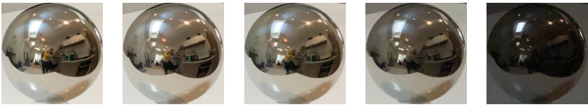

Rescaled log irradiance images from naive method:

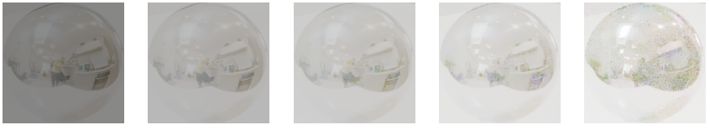

Rescaled log irradiance images from calibration method:

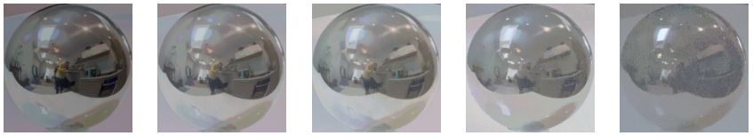

Plot of g vs intensity:

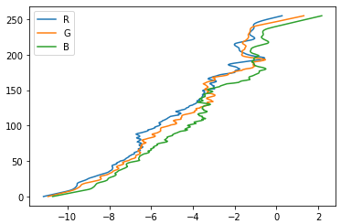

Plot of intensity vs g:

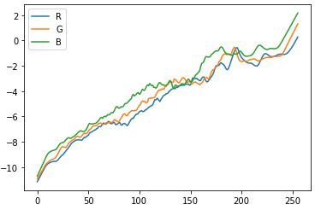

Naive HDR Image:

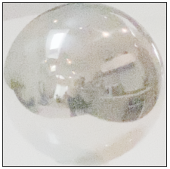

Weighted HDR Image:

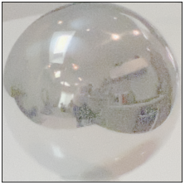

Calibrate HDR Image:

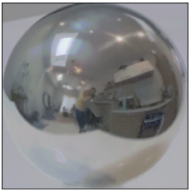

Comparison of the dynamic range and RMS error consistency of the three methods:

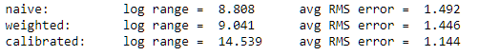

**Answers to additional questions**

1. **For a very bright scene point, will the naive method tend to over-estimate the true brightness, or under-estimate? Why?**

For a very bright scene point, the naive method will tend to under-estimate the true brightness. This is because the naive method assumes a linear camera response curve, i.e., a linear relationship between pixel intensities and irradiance. When comparing bright points, the irradiance should have an exponential relationship to pixel intensities. For instance, the sun is exponentially brighter than a lightbulb; however, when we assume a linear response function, the sun may have a predicted irradiance value that is only a couple times brighter than the sun.

1. **Why does the weighting method result in a higher dynamic range than the naive method?**

Since the naive method assumes a linear mapping between radiance and pixel intensities, for the purposes of computing relative radiance values, we can treat the exposure as equal to the pixel intensity and irradiance as equal to pixel intensity divided by exposure time. Under-exposed scene points will be clipped to irradiance of 0, and over-exposed scene points will be clipped to the maximum possible irradiance value for the image, i.e., 255 / [exposure time] for pixels in the range [0, 255]. These clipped irradiance values will skew the average irradiance of a bright or dark point towards the maximum or minimum value, respectively.

The weighted method is like the naive method except that when computing the average irradiance of LDR images, more weight is given to values in the mid-range of pixel values. Therefore, over-exposed and under-exposed pixels will not dominate the resulting average irradiance. This ultimately means that, when compared the naive method, the computed high dynamic range radiance values from the weighted method will be a more accurate representation of the true scene radiance, which will generally have a large dynamic range.

1. **Why does the calibration method result in a higher dynamic range than the weighting method?**

The calibrated method results in a higher dynamic range, because it estimates the camera response curve so that we can more accurately map pixel values to exposure values. Additionally, we incorporate the weighting function to give a higher weight to exposures that have pixel values in the middle of the response curve, which effectively removes over saturated pixels. The non-linear mapping combined with the weighting results in broader range of irradiance values then just weighting alone. More specifically, in a typical scene, the very bright points and very dark points will map to very large and very small irradiance values, respectively, and the other irradiances will be distributed within smaller range

1. **Why does the calibration method result in higher consistency, compared to the weighting method?**

Irradiances in the calibration method are computed from the exposure values taken from the predicted response function, whereas irradiances from the weighted method are computed by assuming pixel values are linearly related to exposure values. The predicted response function will map most pixel values to exposures within a relatively low range, except for very bright and very dark scene points, which will be mapped to very high and very low exposure values, respectively. This mapping means that the irradiance values are not as impacted by over-exposed or under-exposed points in the scene and exhibit more consistency between each image when compared to the weighted method.

In the weighted method, we assume a linear relation between pixel values and exposure This results in irradiance values that are more sensitive to over-exposed and under-exposed areas of the scenes, and will thus exhibit more variation between images taken with different exposure times.

**Panoramic transformations**

Image of normal vectors:

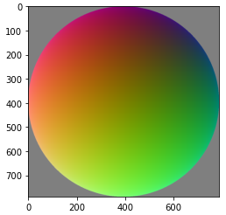

Image of Reflection Vectors:

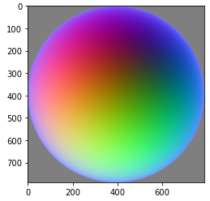

Equirectangular image from calibrated HDR result:

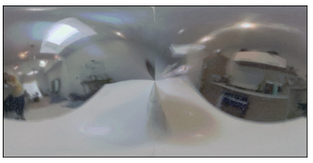

**Rendering synthetic objects**

Background image:



Rendered image with local geometry: 

Rendered image with objects:

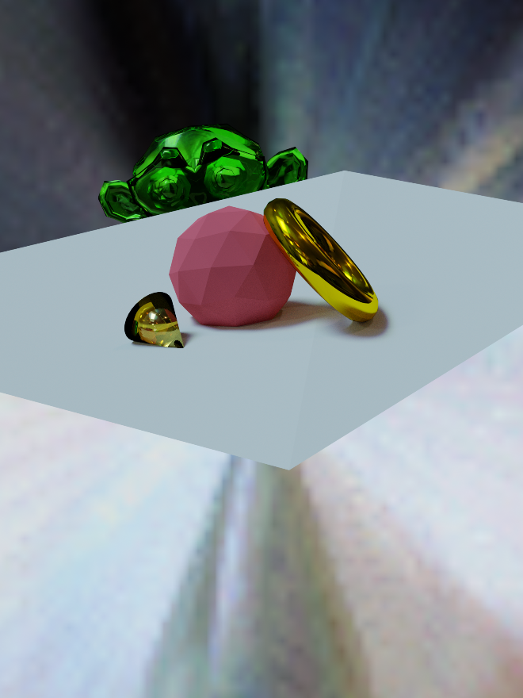

Rendered mask image:

Final composited result:

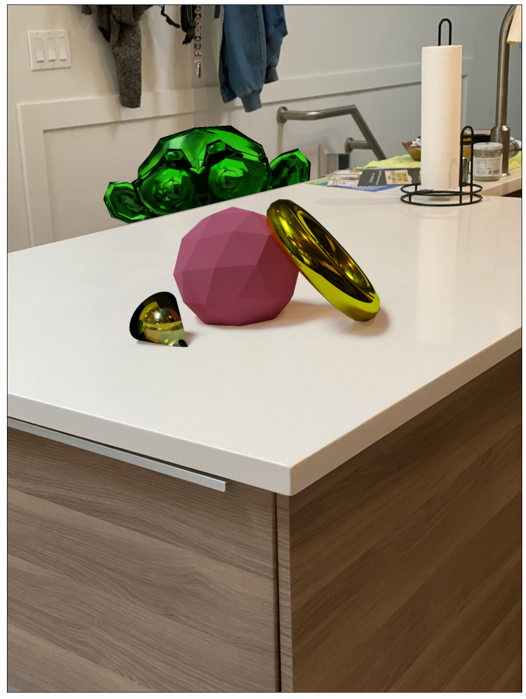

**Additional results (B&W)**

The following example uses the same HDR light map as above.

Background image:



Rendered image with local geometry: 

Rendered image with objects:

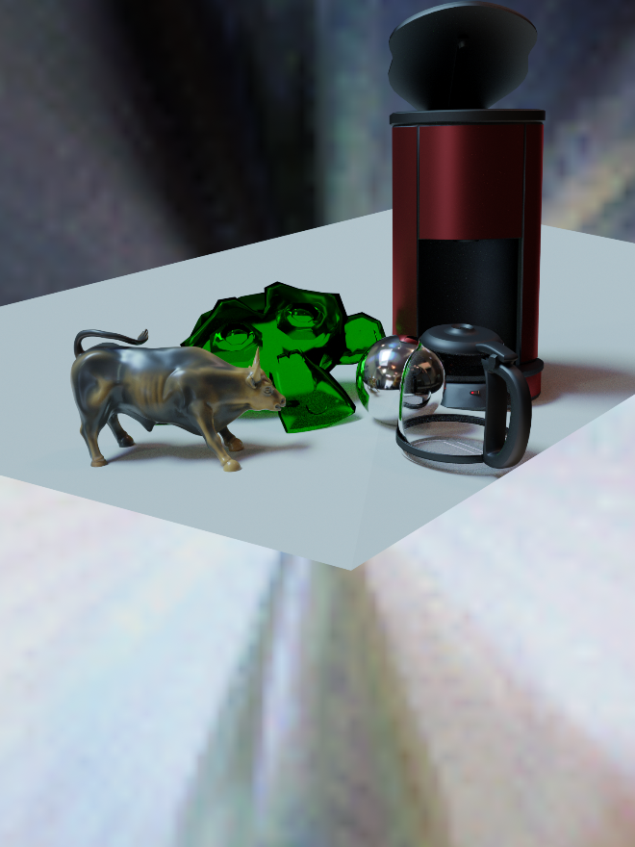

Rendered mask image: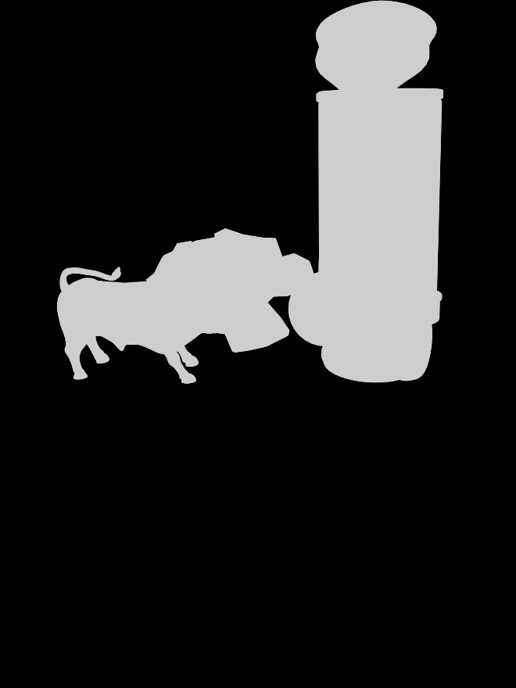

Final composite result: 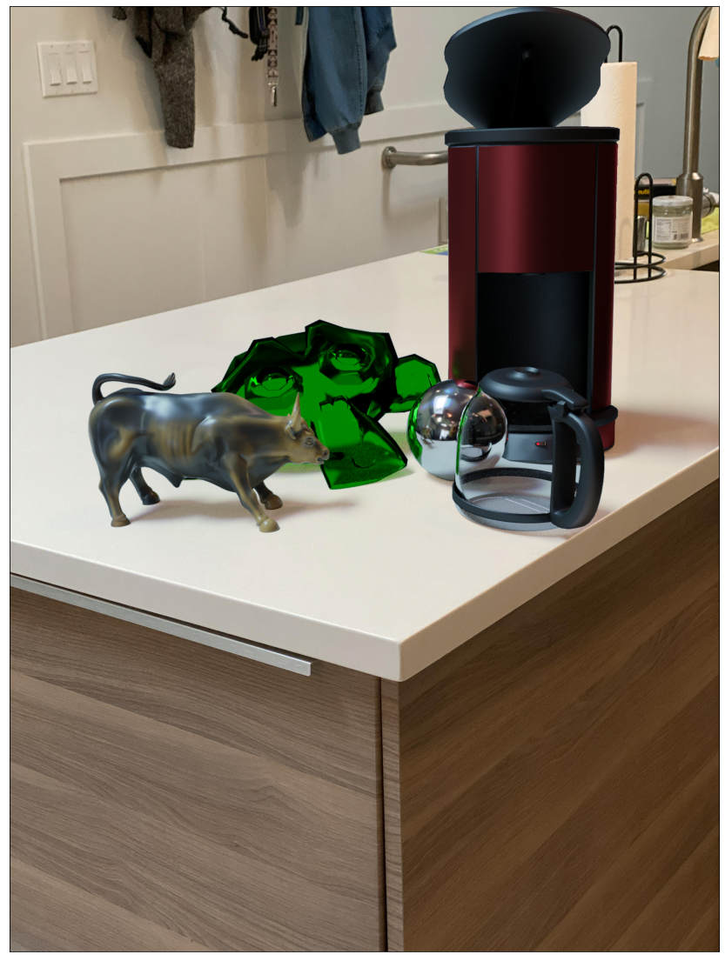

This next example uses a different light map with the same objects:

Background image:

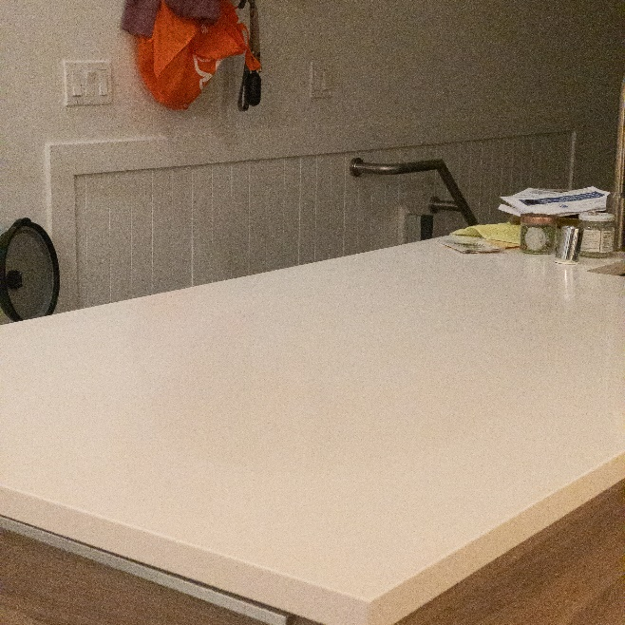

Rendered image with local geometry: 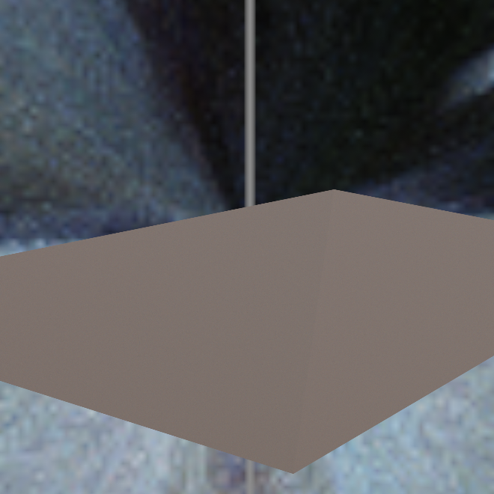

Rendered image with object:

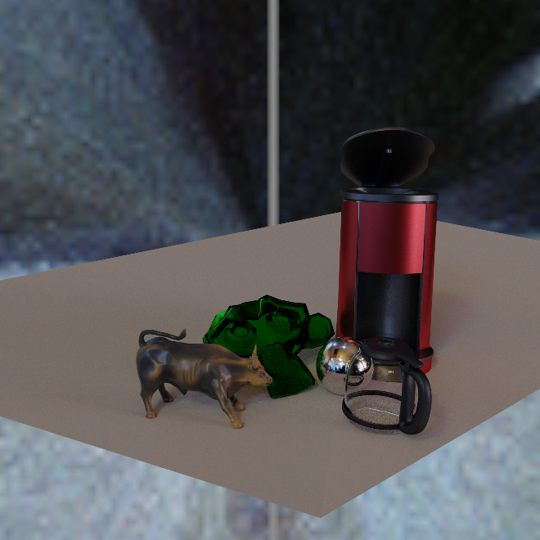

Rendered mask image: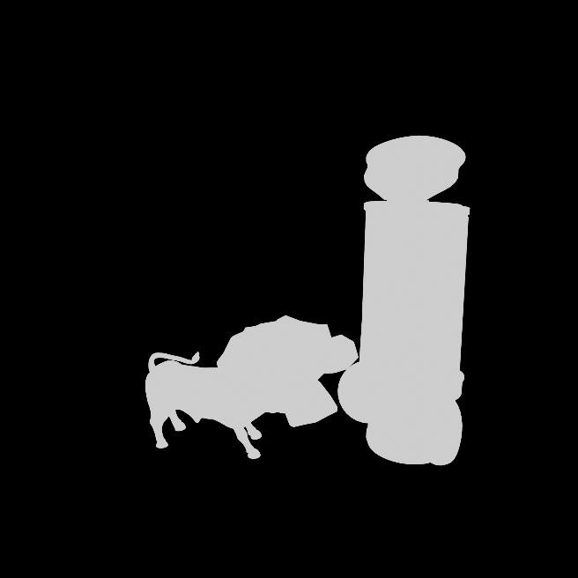

Final composite result:

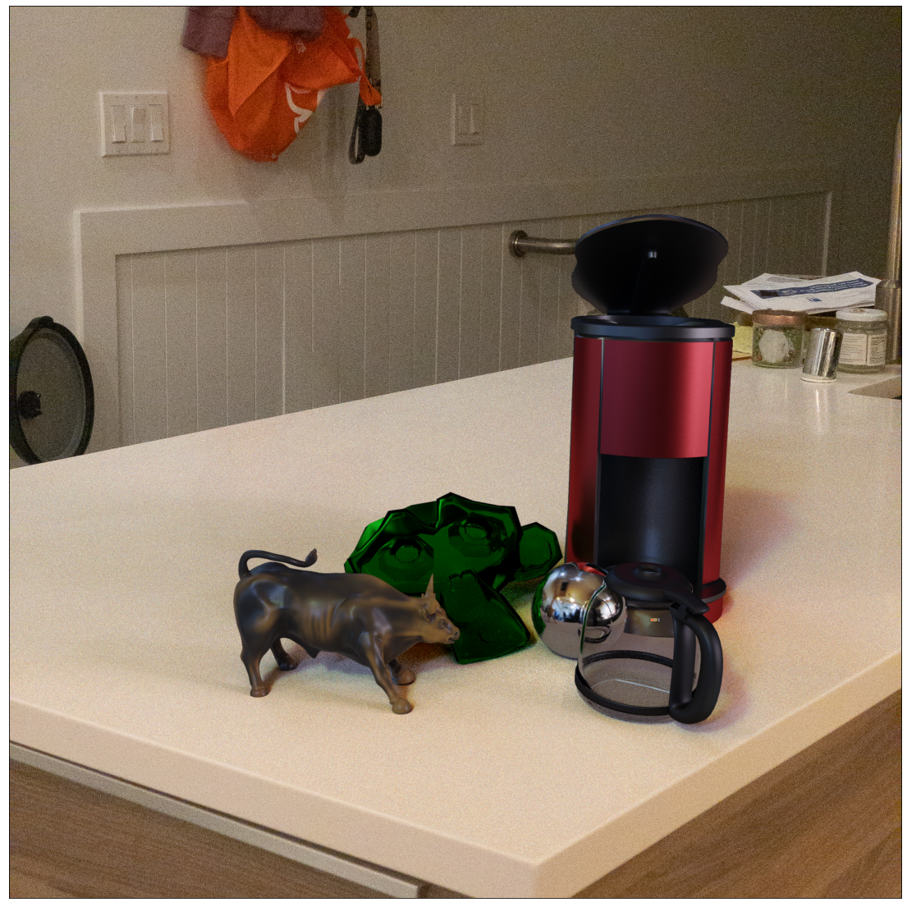

**Acknowledgments / Attribution**

Coffee Maker object: <https://free3d.com/3d-model/coffee-machine-with-rigged-cable--97992.html>

Bull object: <https://free3d.com/3d-model/charging-bull-statue-of-wall-street-v1--959986.html>